Plan of approach
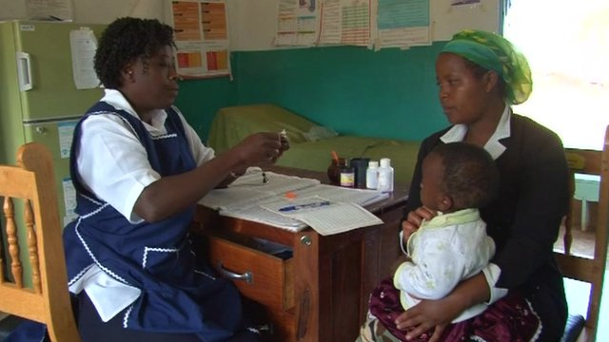

Traditional medicines in Kenya

Made by Lisa, Angela, Alisha & Ashika

INTRODUCTION
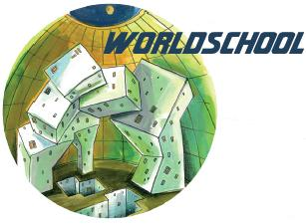
The assignment is to make a report including the answers to a number of questions. These questions are about the health care in Kenya and to answer these questions experts can be interviewed and research can be done.
The main question in this project is: How can we implement the use of evidence-based medicines combined with traditional medicines in Kenya?
The client is the organisation Worldschool and to be precise the contacts are: Jane Sijl & Kiara Snijders.
We would like to do this assignment, because our interests have always been around the medical and natural aspect of the world. We would be thrilled to have a future in this field of study and help people in need with the knowledge that is available and known to mankind. So we chose to do this project.

THE INDEX

- Backgroundinformation

- In reality

- Research

- The desired endproduct

- The expected endproduct

- The research assignment and part assignments

- Description part assignments

- Literature questions

- Schedule

§ 1.1: BACKGROUNDINFORMATION
The project came from an organisation called Worldschool. The organisation has multiple projects from which students can choose from. The main question in this project is: How can we implement the use of evidence-based medicines combined with traditional medicines in Kenya? Various types of traditional medicine (TM) and medical practices referred to as complementary or alternative medicine (CAM), have been increasingly used in both developing and developed countries. One of the major components of the World Health Organization (WHO) Traditional Medicine Strategy is to promote the integration of TM and CAM into national healthcare systems where appropriate. In Africa, access to regular medicine is limited. On average there is only one physician per forty thousand inhabitants. The project is arised by Worldschool, because they found out that the burden of communicable diseases in Kenya is high, with malaria as the leading cause of morbidity (30%) and they want to change this. Their intention is to combine evidence-based medicines with traditional medicines. This is a big problem for the people in Kenya and the organisation would like to solve this project. To increase the knowledge of the country one must first do some research about Kenya itself.

§1.2: IN REALITY
The desired endproduct is a report with all the answered questions and all the researches that are done. This is important for Kenya’s main problem. It will help them accept medicines from outside their original habitat and that will help them prevent dying of an ordinary disease. If the project failes this won’t have a direct influence but eventually the problem will become a bigger problem than it already is. Beside this report there must be an object that you can touch and which can be delivered to the client.
§1.2.1 RESEARCH PART ONE
It is required to do research about the traditional medicines in Kenya. This is requierd to answer the subquestions; What are the main traditional medicines in Kenya and how and for what do they use them? It is important to answer these question for further research.
§1.2.2 RESEARCH PART TWO
It is required to do research about the existing projects. It is very important for the project so that the endproduct isn’t a copy of an already existing project.
§1.2.3 RESEARCH PART THREE
The third research is a research about the communication between the Western world and Kenya.
§1.2.3.2 RESEARCH PART FOUR
The last research is about Malaria. The infection Malaria has been chosen for the project as a subject. This is the most common infection/disease in Kenya. It is important for the project to choose a disease so that the project isn’t too extended. The focus lies with Malaria and the endproduct will be a solution for Malaria, so it is a priority to do some research about it.
§1.2.4 THE DESIRED ENDPRODUCT
The desired endproduct is a report with all the answered questions and all the researches which are done. Beside that there must be an object that you can touch and which can be delivered to the client. It would be nice if the people in Kenya can read our report and can make on this way a better choice of taking evidence-based medicine.
§1.2.5 THE EXPECTED ENDPRODUCT
The expected endproduct is a report with the researches and all the answered questions. There must also be a fysical object which can be delivered to the client like a short movie. The decision about the fysical object will be made during this project.

§2.1: THE RESEARCH ASSIGNMENT AND PART ASSIGNMENTS
The main question in this project is: How can we implement the use of evidence-based medicines combined with traditional medicines in Kenya? There are a few subquestions:
- What are the main traditions in Kenya?
- What are the existing Kenya projects?
- What is the most common disease in Kenya?
- What are the avalaible communication resources in Kenya?
There are also multiple interviews planned with experts and universities.
§2.2.1 DESCRIPTION PART ASSIGNMENTS
The first research is about traditional medicines and traditions in Kenya. Before the project starts it is important to have some knowledge about the situation in Kenya. In the research there will be some information about how the medicines are made and how the residents use them. It’ll be important for this project because the desired endproduct has to answer the main question and to understand this question this research is therefore needed. This reasearch is done 14 september by Ashika and Alisha.
§2.2.2 DESCRIPTION PART ASSIGNMENTS
The second research is about the existing projects. It is necessary for the project that there’s a study about the projects that already exist. It is a priority to come up with something new and not with a reinvented idea. In the research there will be several companies and organisations who help the people in Kenya. This research is finished on 25 September 2015 by Alisha and Lisa. Alisha is reponsible for this assignment.
§2.2.3 DESCRIPTION PART ASSIGNMENTS
The third research is about the most common disease in Kenya. It is required to choose a disease to make the project smaller and less difficult. The most common disease in Kenya is Malaria and for the project it is important to answer the main question. The research starts 28 September 2015 and must be finished on 9 October 2015 by Ashika and Angela. Angela and Ashika are responsible for this.
§2.2.4 DESCRIPTION PART ASSIGNMENTS
The fourth research is about comunication. It is required to give the information in an efffective way to the people in Kenya, so they understand why it is important to take the evidence-based medicines. This will be done at school with a laptop. Ashika and Angela will do this research about comunication and they are responisble for this. The assignment must be done during the end of October and the begin of November. (26-10-2015 - 13-11-2015)

§3.1: LITERATURE QUESTIONS
The main question in this project is: How can we implement the use of evidence-based medicines combined with traditional medicines in Kenya? There are a few subquestions:
- What expertise is available in the Netherlands at universities and research institutes?
- What experiences do other organisations have with comparable projects?
- Would it be possible to interview a number of experts on the following issues?
- How can evidence-based biomedical medicine and African traditional medicine work in concert?

SCHEDULE

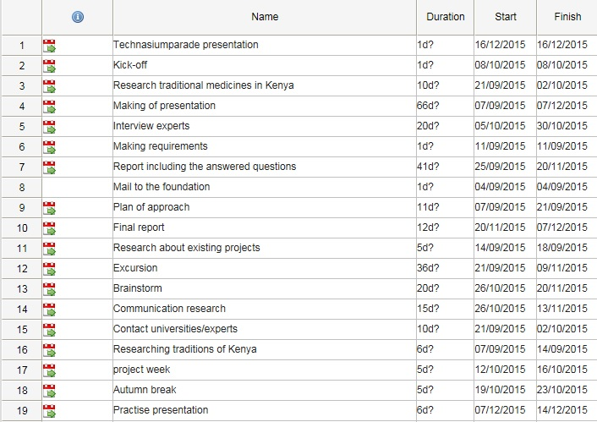
For this project there must be made a planning to get everything on time ready. This is the schedule that is made:

